Bacchanal Buffet NLP -Sentiment Analysis

Customer Comment Analysis for Improving services and customers satisfy for Bacchanal Buffet.

Solution : restaurant.csv

Objectives :
• NLP Supervised Classification on Yelp Dataset
• Sentiment Analysis on Yelp Dataset
• Scraping Foursquare Dataset and Building Sentiment Analysis
• Getting Tweets about business and Building Sentiment Analysis.
• Compare Results

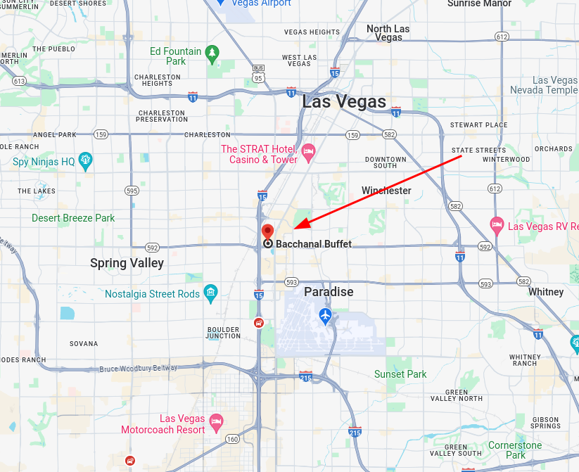
Introduction :

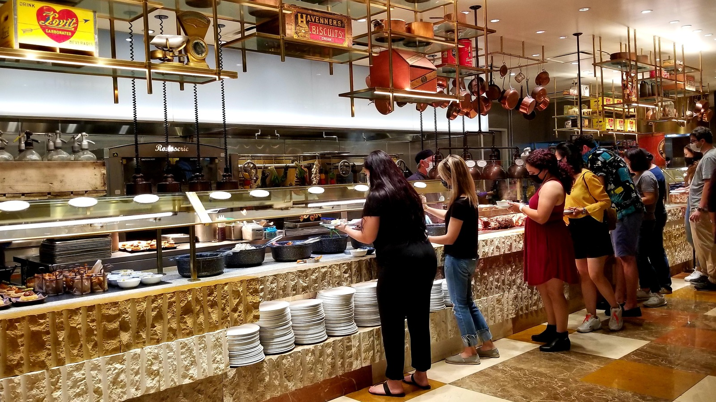

Methodology :
Data Acquire
Exploratory Data Analysis
Text Processing
Modelling
Evaluation

Result :

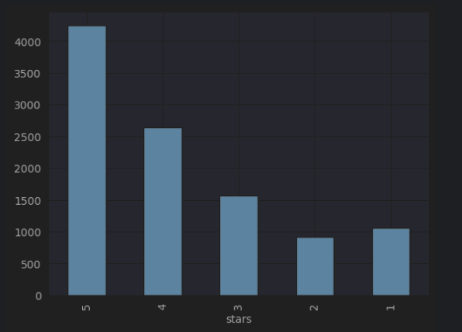

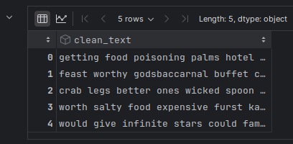

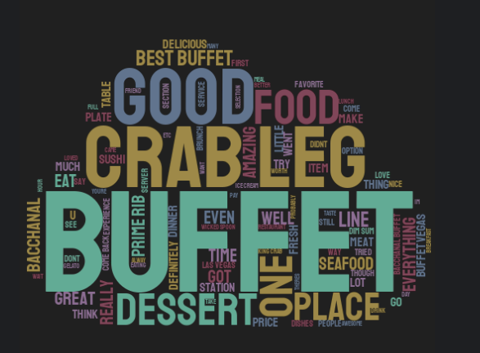

Adding Sentiment Features
1,2 —> Negative
3 —> Neutral
4,5 —> Positive

